Exercise week 4:
Proliferative signaling II (JAK/STAT, MYC, WNT/β-catenin)
1) For memorization:
a) Which cyclin is rate-limiting for cell proliferation and why, and what strategies do cancer cells use to upregulate its expression?
b) What kind of protein is MYC, and why is it so central for multiple hallmarks, including sustained proliferative signaling?
c) Which enzyme controls the degradation of cytoplasmic β-catenin?

2) Reasoning/deduction
Proteins of the JAK family are cytoplasmic tyrosine kinases. How do they become activated, and why does this mechanism make it more complicated and more challenging to find safe inhibitory drugs than in the case of RTKs?

3) Exam-style MCQ:
Which one of the following statements about oncogenic mutations is correct:
- Over 90% of oncogenic mutations in APC increase its affinity for β-catenin
- Mutations in β-catenin are oncogenic if they promote its degradation
- Oncogenic mutations in β-catenin are not randomly distributed across the protein
- Small molecule inhibitors of the kinase GSK3β are used to inhibit β-catenin
- LGR5 encodes a trans-membrane protein that binds frizzled receptors of WNT to mediate negative feedback
4) Role of Wnt signaling in colorectal cancer
a) What findings in humans and in mouse models that we discussed in class speak for or against the notion that hyperactivation of canonical Wnt signaling mediates an early step in tumorigenesis?

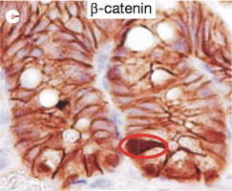
b) You conducted an immunostaining of β-catenin
on a histological section of mouse intestine and
obtained the result shown on the right.
What would be the most likely explanation(s)
for the increased staining in the cell marked
by a red circle?
- downregulation of a diffusible Wnt antagonist
- increased transcription of Tcf
- somatic mutation of the β-catenin destruction
complex
Figure 1. Immunihistochemical staining of β-catenin in two crypts of Lieberkühn.
- Germ line mutation of GSK3β
- increased expression of a Wnt protein

5) Data interpretation: Newly emerging anti-cancer drugs targeting WNT signaling.
Phosphorylation by GSK3β normally is essential for β-catenin to bind its E3 ubiquitin ligase β-TrCP (E3 ligases covalently attach specific lysine residues of their substrates to a polymer of the 7 kDa protein ubiquitin (polyUb) which marks them for proteasomal degradation). As shown in figure 2a, GSK3β sequentially phosphorylates several residues on β-catenin after phosphorylation of the nearby threonine 41 sites by casein kinase 1δ or 1ε (not covered in class). In a screen for small molecules that might be able to “glue” even the GSK3β-resistant mutant oncogenic β-catenin to its E3 ligase, a recent study identified several candidates, including NRX-1933, which was then crystallized in a ternary complex with purified β-cat and β-TrCp (Fig. 2b). Subsequent modifications based on the crystal structure data identified higher affinity binders, including NRX-252114 (Fig. 2c).

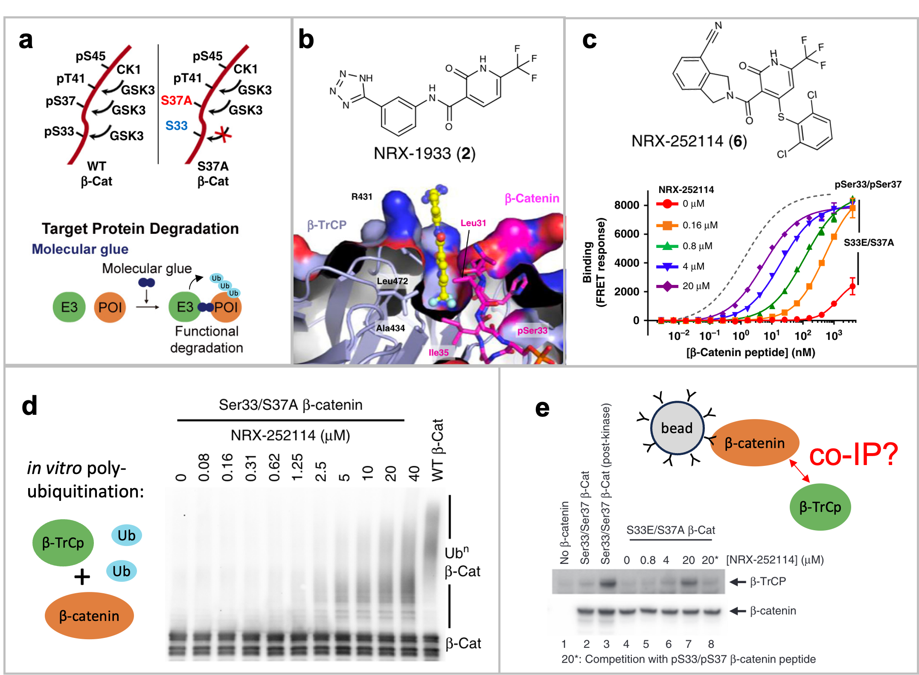
Figure 2. Analysis of NRX-25114 as a molecular glue to target oncogenic mutant β-catenin for degradation.
*
a) Schematic of the proposed phosphorylation cascade for WT and S37A, S33E/S37A mutant β-catenin. Below: Strategy to restore the proteasomal degradation of oncogenic mutant β-catenin by linking it via a small molecule (molecular glue) to the Beta-Transducin Repeat Containing E3 Ubiquitin Protein Ligase (β-TrCp) that normally binds and polyubiquitinates only wild-type β-catenin.
b) Chemical structure of one of the initial candidate molecular glue compounds, NRX-1933. Below:
Cutaway view of a hydrophobic pocket occupied by NRX-1933 in the crystal structure of a complex of β-TrCP with β-catenin.
c) Chemical structure of an optimized molecular glue compound (NRX-252114). Below: A FRET-based assay to measure dose-dependent binding of a S33E/S37A mutant β-catenin peptide to purified β-TrCP in presence of varying NRX-252114 concentrations. The binding curve for the correctly phosphorylated control peptide pSer33/pSer37 from wild-type β-catenin is shown as a stippled grey line. FRET: Förster resonance energy transfer.
d) Western blot of purified wild-type (WT) or S37A mutant β-catenin that were treated with β-TrCp with or without NRX-25114. Asterisk: A non-specific degradation product.
e) Co-immunoprecipitation analysis of β-TrCp binding (red arrow) to WT or S33E, S37A mutant β-catenin on beads coated with anti-β-catenin antibodies. To estimate binding, bead eluates were analyzed by immunoblotting for the presence of β-catenin (bottom) and of co-immunoprecipitated β-TrCp (top). Where indicated, β-catenin was phosphorylated on S33 and S37 by a mix of GSK3, CK1 and Axin prior to loading on beads.

i) To test NRX-252114 efficacy, the authors assessed its impact on the in vitro binding of a fixed amount of β-TrCp to increasing concentrations of a peptide comprising residues 17-48 of β-catenin that was either phosphorylated or mutated on the indicated residues (Fig. 2c). If you compare the colored curves in Fig. 2c with the stippled grey line, what can you conclude about the efficacy of this modified NRX compound?

ii) Figure 2c does not show if NRX also influences the binding of β-TrCp to phosphorylated WT peptide. If it does, would this increase or diminish the therapeutic potential or safety of NRX as an anti-cancer drug? Why or why not?

iii) Treatment with increasing concentrations of NRX was essential for the indicated phosphosite mutant β-catenin to become polyubiquitinated by purified β-TrCP in cell-free assays (Fig. 2d), correlating with significant binding of these proteins to each other (Fig. 2e). In lane 8 of panel (e), the indicated phosphopeptide was added at a molar ratio of 3:1 relative to the phosphomutant full-length β-catenin protein.
Describe the purpose of each of the various specificity controls in lanes 1-3 and 8 what they are supposed to estimate:
Lane 1: Estimates the background of non-specific binding of…
Lane 2: Estimates…
Lane 3:
Lane 8:

iv) Unlike traditional small molecule inhibitors, molecular glues and PROTACs have to bind not only one but two specific target molecules to link those to each other. In terms of thermodynamics, how do you expect this to enhance or diminish drug efficacy?

